Title

Port wise Extension number Mapping

Prepared By
Sandeep Kamarapu

Date:

Version 1.0

Document History

Date | Author | Revision | Description
15-07-2013 | Sandeep Kamarapu |  | Port wise extension number mapping

Approved By: | Tata Business Support Services Limited
Aditya Kilambi | Version 1.0

Distribution List
Name | Department | Company | Rights
Sandeep Kamarapu | Technology – Service Delivery | TBSS | Read and Modify
Aditya Kilambi & Shiva Suraneni | Technology – Service Delivery | TBSS | Verify and Comment
Ali Hyder | Technology – Telecom | TBSS | Full and Approve

Security Classification: Tata BSS Restricted.

Settings for Mapping Extension number at first time:

Step 1: Please send extension numbers to TCC / telecom team to configure additional Auto-In button for enabling auto-in option with notification when he came back from AUX. Once confirmation received from TCC/ Telecom team then start with Step 2.

Step 2: Please un-install Avaya IP soft phone if you have installed soft phone version 5.1.15 and install Avaya IP Soft Phone 5.29 which is given in the below path.

Step 3: Give “full permission” to “Everyone” local security group to Avaya folder which is in “c:\program files” and to registry entry folders.

- HKEY_CURRENT_USERS\SOFTWARE\AVAYA\*
- HKEY_LOCAL_MACHINE\SOFTWARE\AVAYA\*

Step 4: Copy iClarityAdmin.exe from specified path and paste this exe file in to C:\Program Files\Avaya\Avaya IP Softphone.

Step 5: Copy registry file “iclarity.reg” ad paste this registry file in to c:\windows\

Step 6: Copy VB script file “ipsoftoptions” in to “C:\Documents and Settings\All Users\Start Menu\Programs\Startup”

Step 7: Please give “full permission” to “Everyone” local security group to script file “ipsoftoptions”

For configuring Extension number:

Step1: Go to c:\windows and open “iclarity.reg” then change the extension number and System IP address details and Call server IP details (if locations have specific IP) as per the screen shot.
Screen Shot:
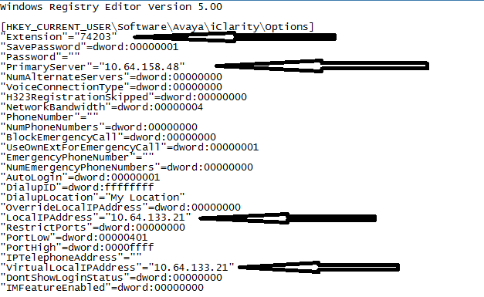

Step 2: Once Entries are edited in the registry file in the machine then run “ipsoftoptions” script file after saving registry file accordingly.

Once everything done, Agent required to give only extension password instead of configuring everything and he can able to login with his credential after logging in to extension.

THANK YOU

